**Pet Finder**

My application is designed for the adoption of pets, but also for finding homeless animals and giving them to adoption. Also, there are shelters that have a manager. Any animal can be added to favorites and requested.

Users have the possibility to sign up and log in as a simple user and the shelters’ managers have predefined accounts.

The project has 9 views and 2 methods of login.

I used enumerations for colors and I used them in the ShelterView.

I used override in InfoBreedsView.

The database connection is done in repository classes.

**LoginView:**

In the log in view, users have to enter their username and password. If they don’t have an account, they can create one clicking on “Sign Up” button. The little checkbox allows the users to see their password.

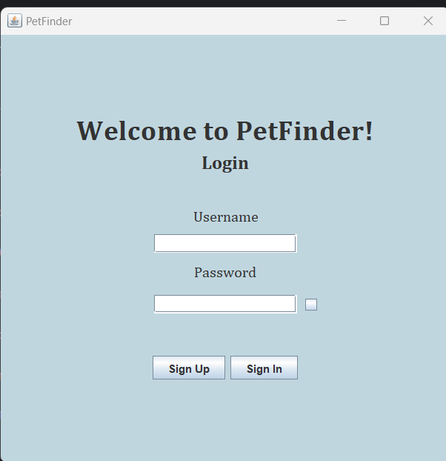

**SignUpView:**

An account is created with the user’s personal information: name, date of birth, gender, city and county, phone number, email and username. The username must be unique and the email has a specific form with “@gmail/yahoo.com” at the end.

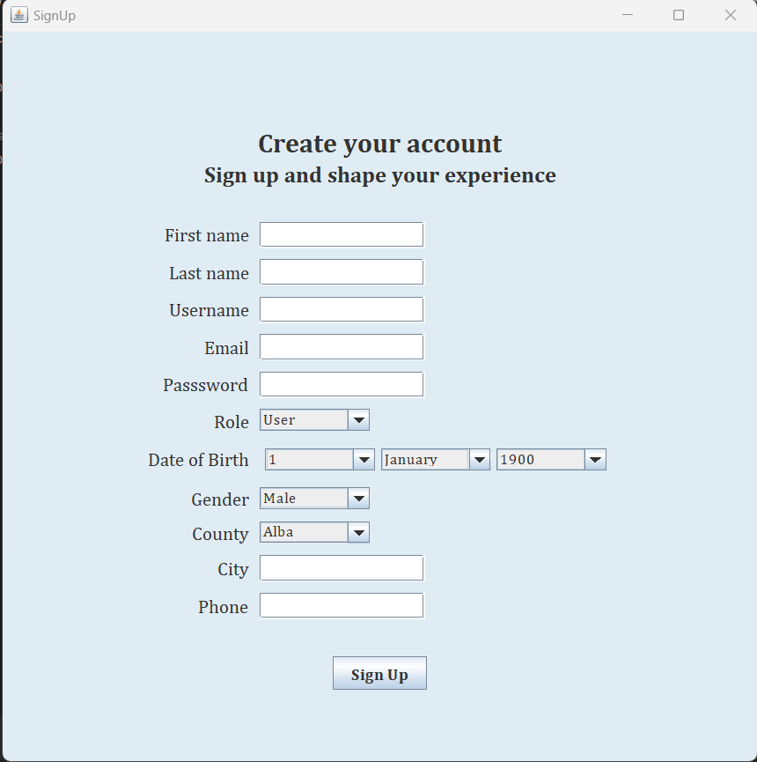

**HomePageView (for user):**

After a successful login, users are redirected to the HomePage. Here, they can choose from various options: view their account, post an animal, search for an animal, and access information about animals’ breeds. The user's name is displayed in the right upper corner for easy identification.

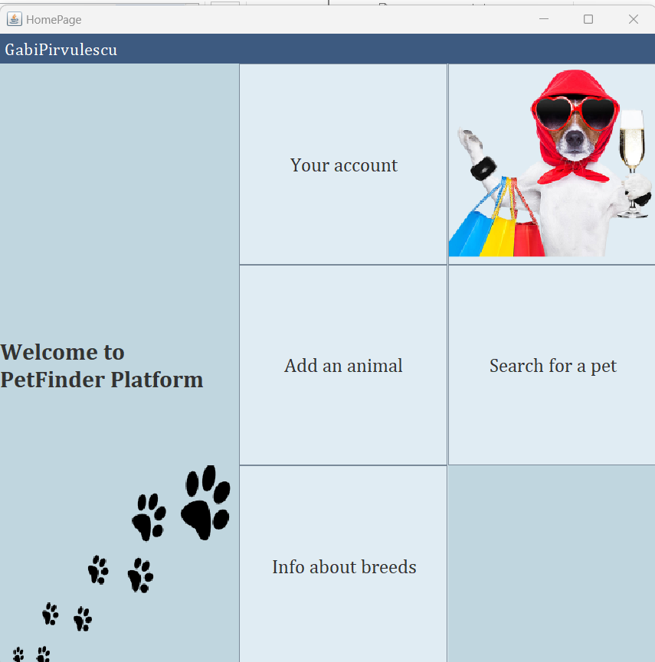

**AccountView:**

Users can view their profile, including personal information and the list of animals they added. To remove an animal, simply click on the "Delete" button. Users also have the option to change their username. For easy navigation, a button in the left corner redirects them to the HomePage. 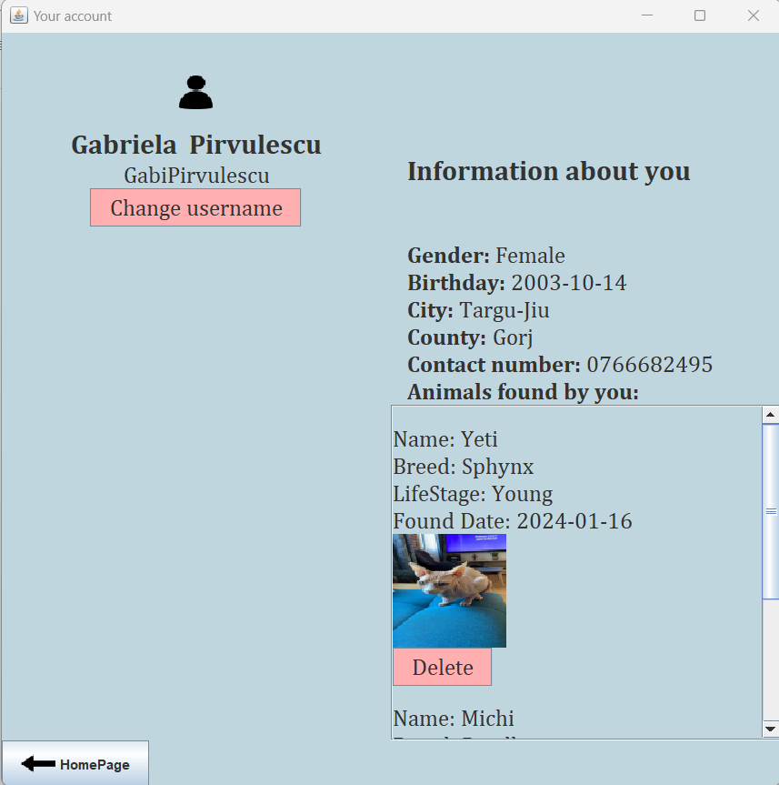

**InfoBreedView:**

Here, users can access information about animals' breeds. They start by selecting their desired category from the combo box. To view the corresponding information, they should click on the "Update Table" button.

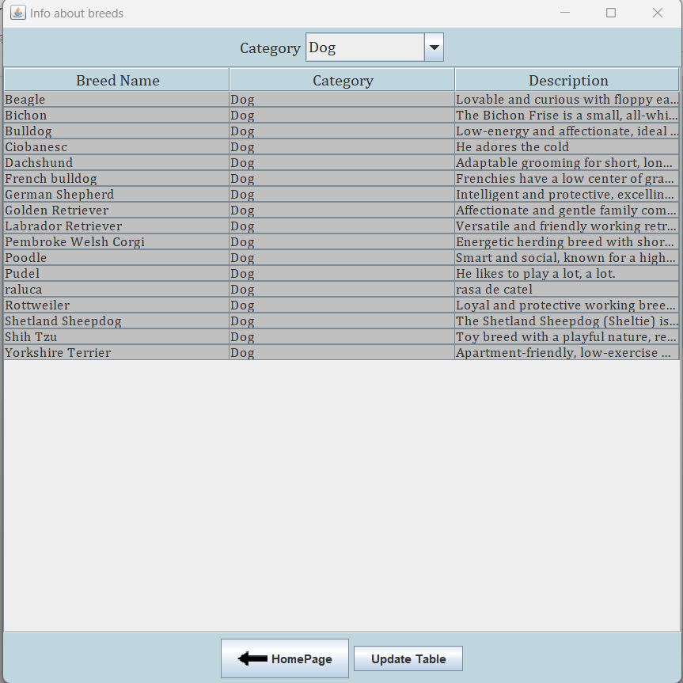

**AddAnimalView:**

Users can add an animal by providing essential information such as category, age, breed, gender, color, description, the location where they found the animal, and a photo. Upon clicking the "Add" button, the details will be submitted to post the animal.

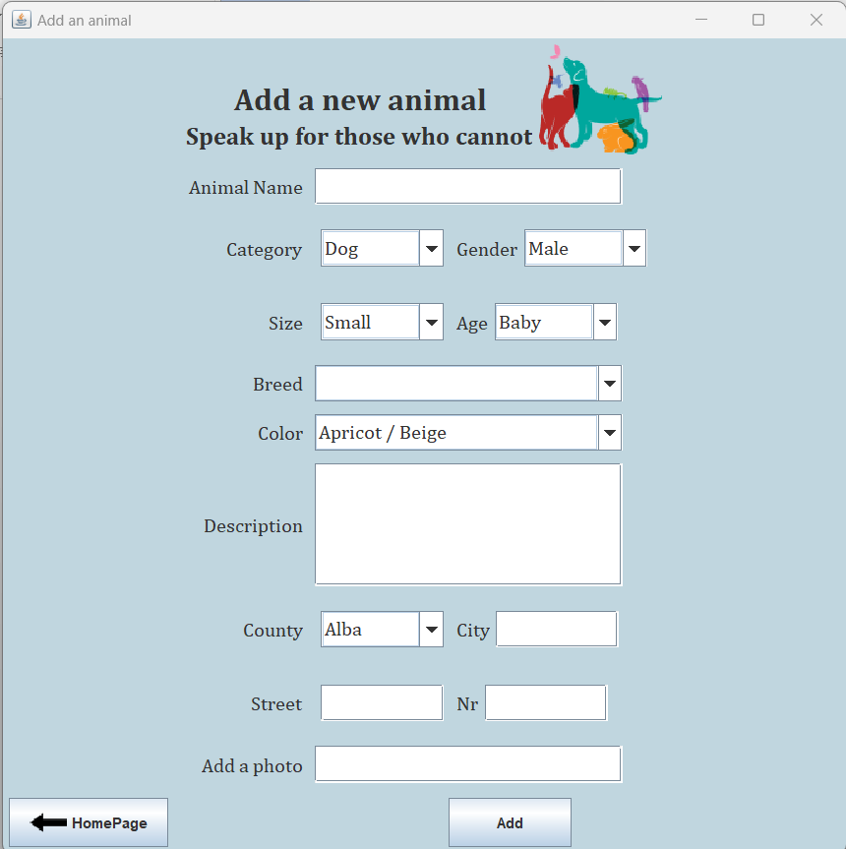

**SearchAnimalView:**

In the SearchPetView, users have the ability to search for an animal based on criteria such as category, breed, and city.

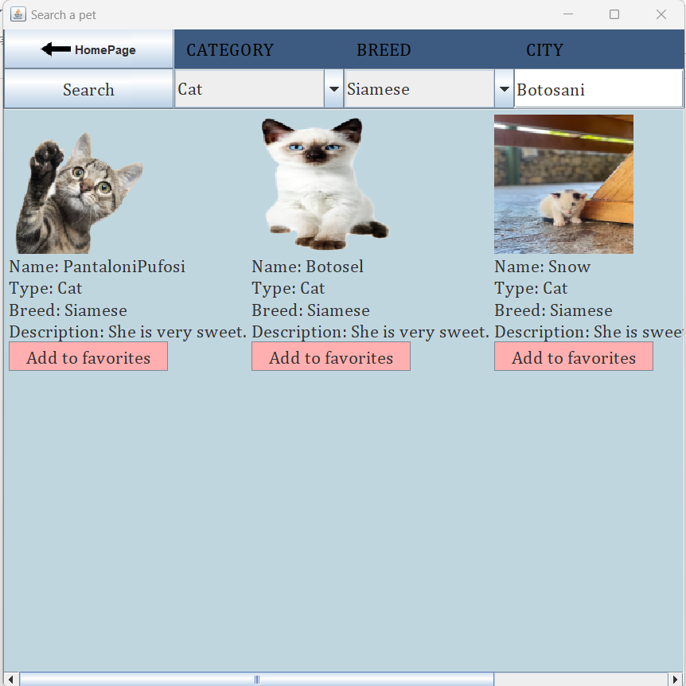

**HomePageView (for the manager):**

Clicking on this button, the manager can add new breeds.

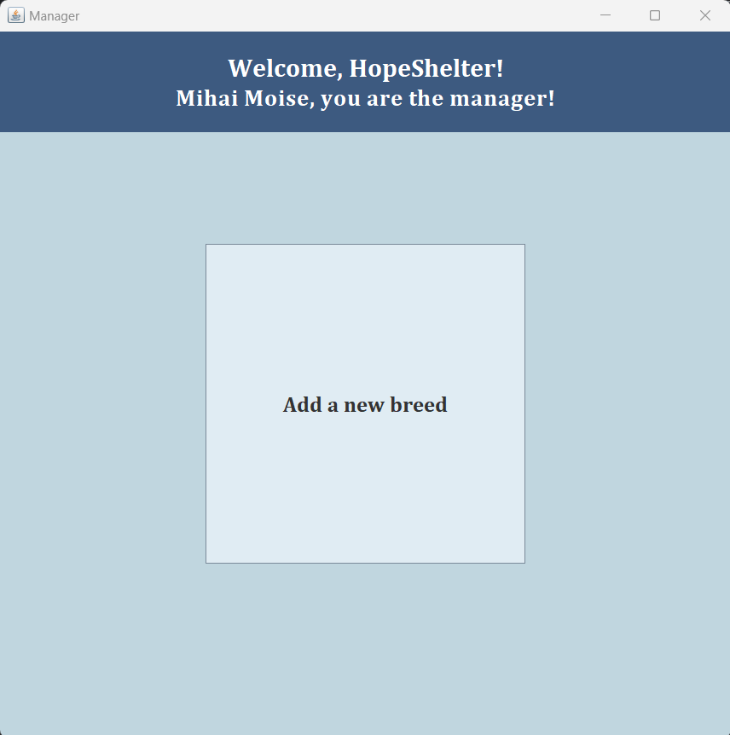

**AddNewBreedView:**

To create a new breed, the manager needs to provide the breed name and a description. Clicking on "See breeds" allows the manager to review comprehensive information about different breeds.

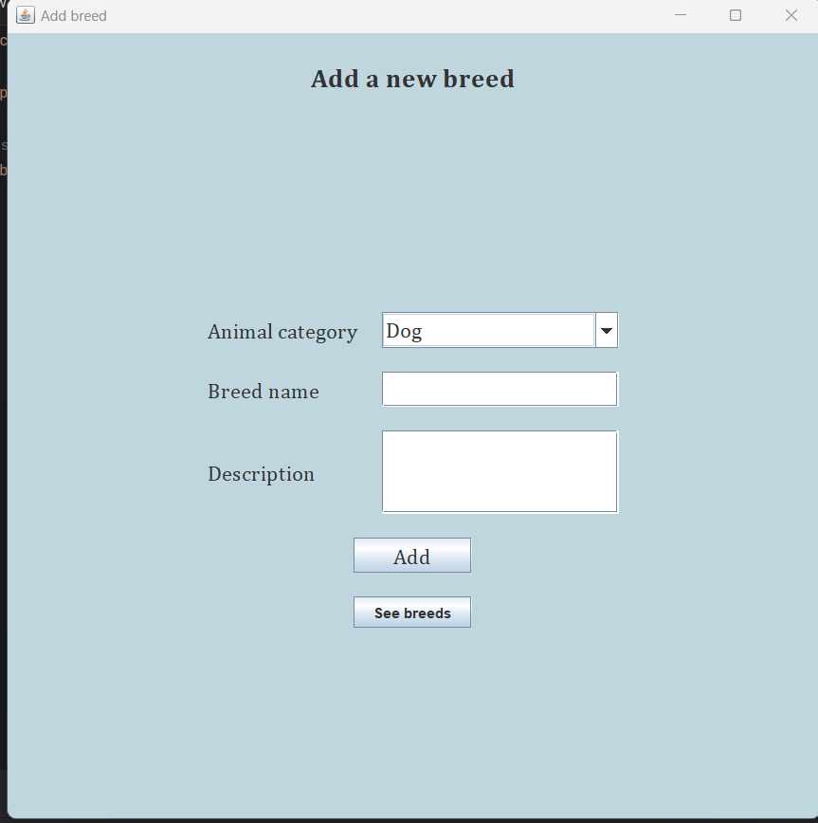

**Database diagram:**

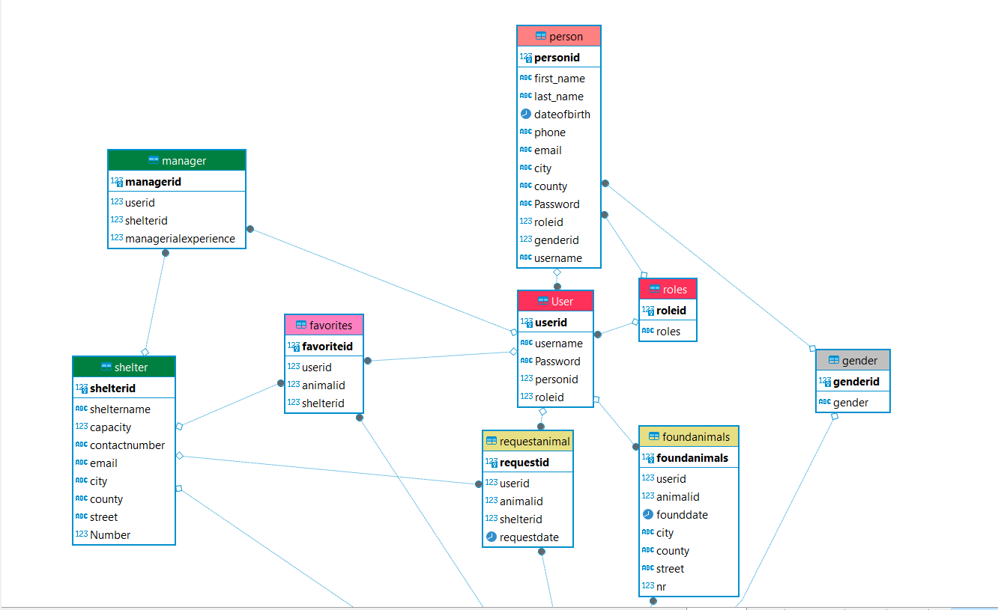

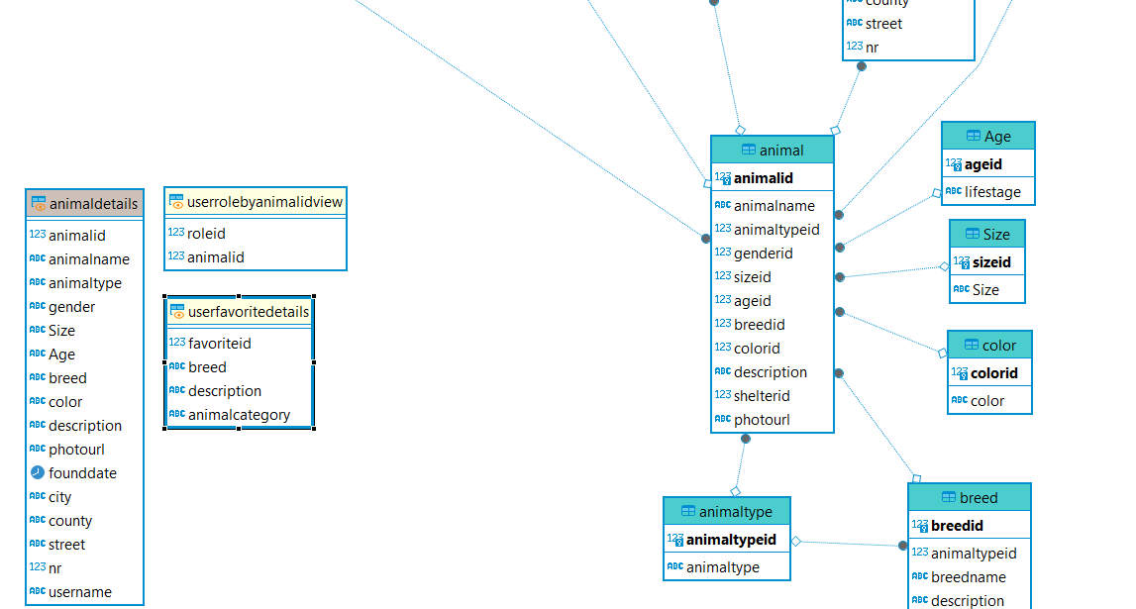

For manager authentification:   
 username: HopeShelter  
 password: hope

For an account where animals are already added:

Username: GabiPirvulescu

Password: gabi

To search a pet where you will for sure find animals, you can use the following criteria: Cat, Siamese, Botosani.